**HOSPITAL MANAGEMENT APPLICATION**

**USING SQL & MongoDB**

By

Jayalakshmi Vaidyanathan

**HOSPITAL MANAGEMENT**

1. **INTRODUCTION:**

Data Management is one of the major challenges in Healthcare. Hospitals struggle to store and manage the patients records and images from various tests and surgeries carried out. Medical Reports are the most intensive and diverse in Hospital Management Information System. This application works on a hybrid model that combines both SQL Data base and MongoDB to solve the data storage and management challenges

* 1. **Scope:**

The hospital application provides solution for the following:

1. Patient profile management using SQL
2. Diagnosis management Using SQL
3. Billing Management Using SQL
4. Revenue and other Business Management Reports Using SQL
5. Repository for Lab reports,images and scans, using large files handling features of MongDB
6. **USERS:**

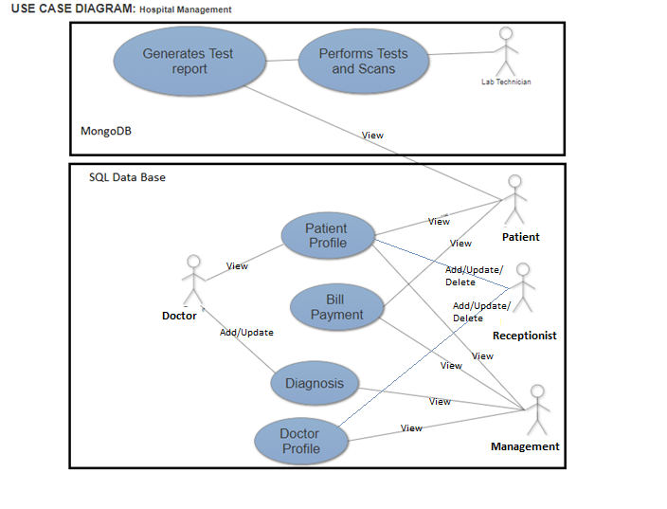

1. **Doctor:**

* Updates Diagnoses details about the patients
* Reads the patients history
* Reads patient’s Lab reports

1. **Patient:**

* Views his profile, Diagnosis and test report
* Makes bill payments

1. **Receptionist:**

* Adds, Updates, deletes Patient’s profile
* Adds, Updates, deletes Doctor’s profile

1. **Management:**

* View profiles of Doctors, patient and payments for business management purpose

1. **Lab Technician:**

* Conducts all lab tests and records the test results and scanned images

1. **USE CASE:**
2. **Patient Details Management**

* All the registered patients are recorded in tables.
* The Patients are provided with their profile login
* Doctors view the patient’s details
* The hospital Management can also view the information for business purpose

1. **Diagnosis Details Management**

* The doctor updates every diagnosis of patients visiting for consultation
* The patients can view the updated data
* The hospital Management can also view the information for business purpose

1. **Billing Management**
   * 1. Payments made by patients are recorded
     2. The hospital Management can also view the information for business purpose
2. **Lab Data Management**
   * 1. Lab Technician updated the scan and other test reports
     2. Doctors can view their patient’s reports
     3. Patients can view their reports online
3. **USER INTERFACE:**
   * + 1. **Login**

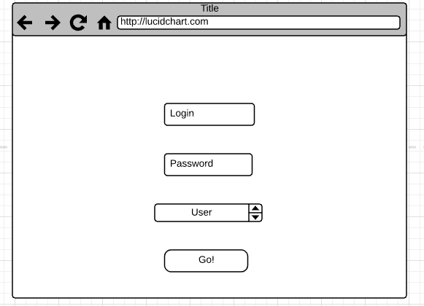

**Login**: Based on whether the user is a patient, doctor or admin, the login page will lead to corresponding user interface. The User can be chosen from the dropdown box. Once the credentials are validated, it guides to the corresponding user portals mentioned below.

* + - 1. **Patient’s Profile**

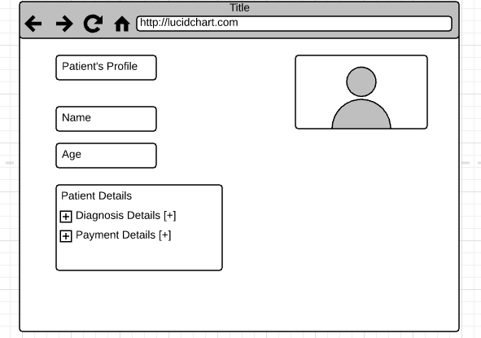

**Patient’s Profile:** The patients can access the above page to view their hospital details

* + - 1. **Diagnosis Details**

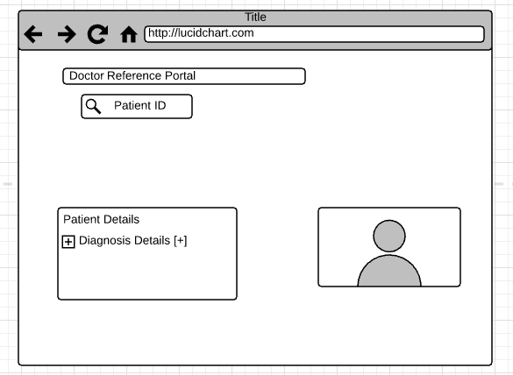

**Diagnosis Details:** Doctors can view the patient’s history from the above portal

* + - 1. **Management**

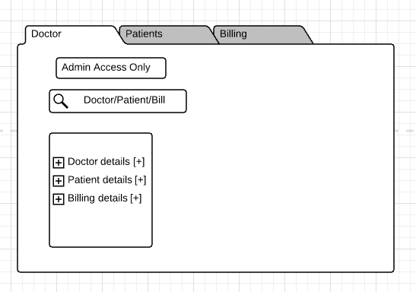

The management can view all the details about the doctors, patients and financial information from then above portal.

1. **Lab Reports**

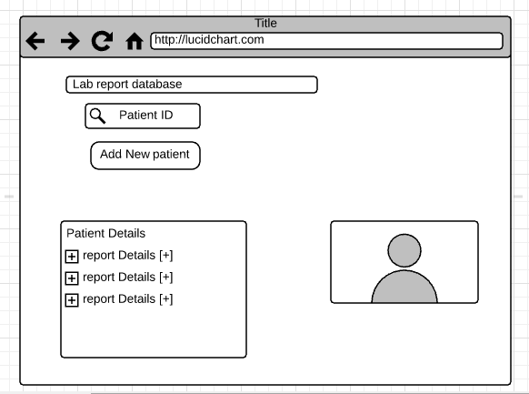

**Lab Report:** The Lab technicians can update the test results, images and scan in then above portal

1. **SQL Vs NoSQL:**
2. **SQL:**

The below use cases are handled in SQL. Due to ACID property of SQL, they are used for transactional processes , where we require structured data handling systems and consistent data retrieval.

1. **Patient Record Detail**

All the patient’s profile details have to be stored and retrieved whenever the patient or doctor wishes to view them. The data retrieval has to be consistent and precise. Also, the details of all patients follow structured pattern. In such a case SQL is the appropriate solution

1. **Diagnosis Details Management**

When a patient visits a doctor, the doctor has to update patient’s diagnosis details. This has to be available to patients when he /she views his/her profile. The data has to be appropriate and instantly updated. SQL is better option as they provide structured and consistent data retrieval.

1. **Billing Management**

The payment of bills by the patients has to be secured and involves the same kind of transactions throughout. In such situation where it involves consistent, secured and homogenous transaction SQL is the best choice.

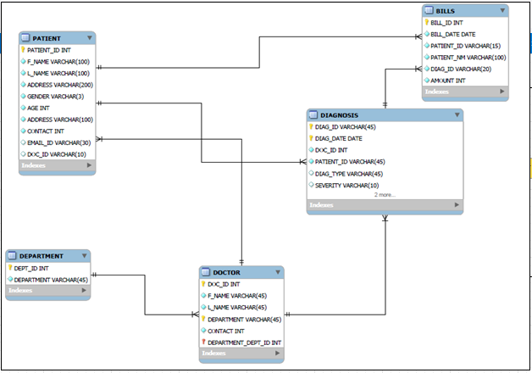

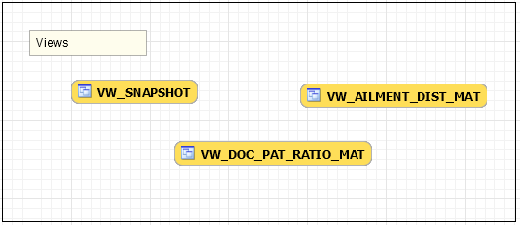

**SQL – UML Diagram**

1. **NoSQL:**

**Lab Data Management**

There are variety of tests that are conducted to patients which ranges from a simple blood tests to MRI scans. Each patient produces voluminous and varied data for every lab test. In such case, handling lab data in a structured environment will be very difficult. More flexible environment like NoSQL is needed. The BASE property of NoSQL helps in storing and managing different test results in an easy fashion and also data retrieval is faster in case of large data. The file system handling features like mongofiles and GridFS provides solutions for handling very large files greater than 16MB as well. Handling images and videos are also tedious process in SQL

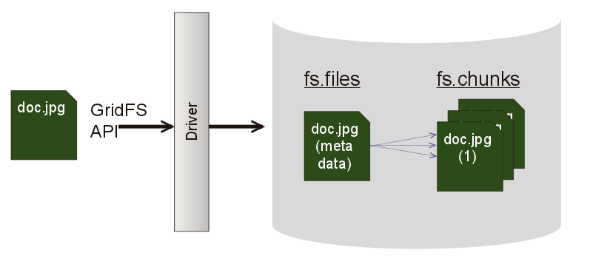

1. **QUERY ENUMERATION:**
2. **Patient Details Management**

* **Patient Login:** Patient ID and password must match to access his profile
* **Receptionist:** Needs to add, update and delete the patient profile details if needed
* **Doctor** has to view the patient’s details
* **Management** can View patient’s details

1. **Diagnosis Details Management**

* **Doctor** needs to add or update for each consultation
* **Patient** can view the updated data
* **Management** can view for Business analysis reports

1. **Billing Management**

* **Patient** can view the payments
* **Receptionist** can add or update the billing details
* **Management**  can view for Business analysis reports

1. **Lab Data Management**

* **Lab technician can add or** update the test results and reports
* **Doctors** can view the reports
* **Patients** can view the reports

1. **BUSINESS METRICS:**
2. Overall Snapshot of the hospital management
3. Revenue Metrics
4. Doctor to Patient Ratio
5. Gender wise Ailment Frequency
6. Department wise revenue report
7. **Design Database Schema & MongoDB structure**
8. **SQL**
9. **TABLES**

* DOCTOR

|  |  |  |  |  |  |  |
| --- | --- | --- | --- | --- | --- | --- |
| **COLUMN** | **DATATYPE** | **NULL/NOT NULL** | **AUTO INCREMENT** | **PRIMARY KEY?** | **FOREIGN KEY?** | **INDEX** |
| DOC_ID | INT | NOT NULL | Y | Y | Y | Y |
| F_NAME | CHAR(30) | NOT NULL |  |  |  |  |
| L_NAME | CHAR(30) | NOT NULL |  |  |  |  |
| DEPARTMENT | VARCHAR(30) | NOT NULL |  |  |  |  |
| CONTACT | VARCHAR(20) | NOT NULL |  |  |  |  |
| EXPERIENCE | INTEGER(9) | NOT NULL |  |  |  |  |

**PRIVILIGES**

|  |  |
| --- | --- |
| **USER** | **PRIVILIGES** |
| Receptionist | INSERT,UPDATE |
| Management | SELECT |
| Patient | SELECT |

* PATIENT

|  |  |  |  |  |  |  |
| --- | --- | --- | --- | --- | --- | --- |
| **COLUMN** | **DATATYPE** | **NULL/NOT NULL** | **AUTO INCREMENT** | **PRIMARY KEY?** | **FOREIGN KEY** | **INDEX** |
| PATIENT_ID | INT | NOT NULL | Y | Y |  | Y |
| F_NAME | CHAR(30) | NOT NULL |  |  |  |  |
| L_NAME | CHAR(30) | NOT NULL |  |  |  |  |
| GENDER | CHAR(12) | NOT NULL |  |  |  |  |
| ADDRESS | VARCHAR(256) | NOT NULL |  |  |  |  |
| CONTACT | VARCHAR(20) | NOT NULL |  |  |  |  |
| EMAIL_ID | VARCHAR (100) | NULL |  |  |  |  |
| DOC_ID | VARCHAR(10) | NOT NULL |  |  | Y |  |

**PRIVILIGES**

|  |  |
| --- | --- |
| **USER** | **PRIVILIGES** |
| Receptionist | INSERT,UPDATE |

* DIAGNOSIS

|  |  |  |  |  |  |
| --- | --- | --- | --- | --- | --- |
| **COLUMN** | **DATATYPE** | **NULL/NOT NULL** | **AUTO INCREMENT** | **PRIMARY KEY?** | **FOREIGN KEY** |
| DIAG_ID | INT | NOT NULL | Y | Y |  |
| DIAG_DATE | DATE | NOT NULL |  |  |  |
| DOC_ID | VARCHAR(20) | NOT NULL |  |  | Y |
| PATIENT_ID | INT | NOT NULL |  |  | Y  ON DELETE CASCADE |
| DIAG_TYPE | VARCHAR(45) | NULL |  |  |  |
| SEVERITY | VARCHAR(10) | NULL |  |  |  |
| TREATMENT | VARCHAR(45) | NULL |  |  |  |
| PRESC_DRUGS | VARCHAR(45) | NULL |  |  |  |

PRIVILIGES

|  |  |
| --- | --- |
| **USER** | **PRIVILIGES** |
| DOCTOR | INSERT,UPDATE |
| PATIENT | SELECT |

* DEPARTMENT

|  |  |  |  |  |
| --- | --- | --- | --- | --- |
| **COLUMN** | **DATATYPE** | **NULL/NOT NULL** | **AUTO INCREMENT** | **PRIMARY KEY?** |
| DEPT_ID | INT | NOT NULL | N | Y |
| DEPT_NAME | VARCHAR(45) | NOT NULL | N |  |

PRIVILIGES

|  |  |
| --- | --- |
| **USER** | **PRIVILIGES** |
| Managenment | SELECT |

* BILL

|  |  |  |  |  |  |  |
| --- | --- | --- | --- | --- | --- | --- |
| **COLUMN** | **DATATYPE** | **NULL/NOT NULL** | **AUTO INCREMENT** | **PRIMARY KEY?** | **FOREIGN KEY** | **INDEX** |
| BILL_ID | INT | NOT NULL | Y | Y |  |  |
| BILL_DATE | CHAR(30) | NOT NULL |  |  |  | Y |
| PATIENT_ID | CHAR(30) | NOT NULL |  |  | Y  ON DELETE CASCADE |  |
| PATIENT_NM | CHAR(12) | NOT NULL |  |  |  |  |
| DIAG_ID | VARCHAR(256) | NOT NULL |  |  | Y |  |
| AMOUNT | DECIMAL | NOT NULL |  |  |  |  |

**PRIVILIGES**

|  |  |
| --- | --- |
| **USER** | **PRIVILIGES** |
| PATIENTS | SELECT |
| Receptionist | INSERT,UPDATE |

1. **VIEWS**

* VW_SNAPSHOT

CREATE VIEW VW_SNAPSHOT AS

SELECT

D.DOC_ID,

CONCAT(D.F_NAME,' ',D.L_NAME) AS DOCTOR,

P.PATIENT_ID,

CONCAT(P.F_NAME,' ',P.L_NAME) AS PATIENT,

DG.DIAG_DATE ,

DG.DIAG_TYPE ,

DG.SEVERITY ,

DG.TREATMENT ,

DG.PRESC_DRUGS ,

B.AMOUNT

FROM DOCTOR D

JOIN

PATIENT P

ON D.DOC_ID = P.DOC_ID

JOIN DIAGNOSIS DG

ON P.PATIENT_ID = DG.PATIENT_ID

AND D.DOC_ID = DG.DOC_ID

JOIN BILL B

ON P.PATIENT_ID = B.PATIENT_ID AND

DG.DIAG_ID = B.DIAG_ID

ORDER BY DG.DIAG_DATE;

* VW_DOC_PAT_RATIO_MAT

CREATE VIEW VW_DOC_PAT_RATIO_MAT AS

SELECT

CONCAT(D.F_NAME,' ',D.L_NAME) DOCTOR_NAME,

COUNT(P.PATIENT_ID)

FROM DOCTOR D

JOIN

PATIENT P

ON D.DOC_ID = P.DOC_ID

JOIN DIAGNOSIS DG

ON P.PATIENT_ID = DG.PATIENT_ID

AND D.DOC_ID = DG.DOC_ID

GROUP BY D.DOC_ID

ORDER BY DG.DIAG_DATE;

* VW_AILMENT_DIST_MAT

CREATE VIEW VW_AILMENT_DIST_MAT AS

SELECT

P.GENDER ,

DG.DIAG_TYPE,

COUNT(P.PATIENT_ID) COUNT

FROM

PATIENT P

JOIN DIAGNOSIS DG

ON P.PATIENT_ID = DG.PATIENT_ID

GROUP BY P.GENDER,DG.DIAG_TYPE

ORDER BY P.GENDER,DG.DIAG_TYPE;

1. **STORED PROCEDURE**

* PROC_REVENUE_METRIX

CREATE PROCEDURE PROC_REVENUE_METRIX

AS

BEGIN

SELECT A.YEAR,

A.MONTH,

SUM(A.AMOUNT) AS REVENUE_MAT

FROM (SELECT

EXTRACT(MONTH FROM BILL_DATE) AS MONTH,

EXTRACT(YEAR FROM BILL_DATE) AS YEAR,

AMOUNT

FROM BILL ) A

GROUP BY A.YEAR,A.MONTH

ORDER BY A.YEAR,A.MONTH

END;

1. **NoSQL**
2. **DATABASE**
   1. Gridfs
3. **COLLECTIONS:**
   1. Patient
   2. Db.ctFiles.files
   3. Db.ctFiles.chunks
      * 1. **Patients**

{"Patient_id":11221,

"Patient_name":"SIMON TAYLOR",

"gender":"MALE",

"Age":"50",

"Adderess":"LONDON",

"Contact":"877-609-2983",

"Email_id":"taylor @email.com","Doc_id":"1101" }, ……..

**B.fs.chunks**

{

"files_id": ObjectId("574a65c19f54bfea8a2fa46b"),

"n": NumberInt(0),

"data": "Mongo Binary Data"

} …..

C.fs.files

{

"filename": "sample.jpeg",

"chunkSize": NumberInt(261120),

"uploadDate": ISODate("2017-11-28T11:32:33.557Z"),

"md5": "7b772939325e146578b07f72c62bba4f",

"length": NumberInt(645)

}

1. **DATABASE POPULATION**
2. **SQL:**

**DDL and Scripts:**

CREATE TABLE DOCTOR (

DOC_ID INT NOT NULL UNIQUE ,

F_NAME CHAR(30) NOT NULL,

L_NAME CHAR(30) NOT NULL,

DEPARTMENT VARCHAR(30) NOT NULL,

CONTACT VARCHAR(20) NOT NULL,

EXPERIENCE INTEGER (9) NOT NULL,

CONSTRAINT doc_pkey PRIMARY KEY (DOC_ID)

);

CREATE INDEX idx_doc_doc_id ON DOCTOR (DOC_ID);

GRANT INSERT,UPDATE ON DOCTOR TO receptionist;

GRANT SELECT ON DOCTOR TO management;

CREATE TABLE PATIENT (

PATIENT_ID INT NOT NULL UNIQUE ,

F_NAME CHAR(30) NOT NULL,

L_NAME CHAR(30) NOT NULL,

GENDER CHAR(12) NOT NULL,

AGE INT(3) NOT NULL,

ADDRESS VARCHAR(256) NOT NULL,

CONTACT VARCHAR(20) NOT NULL,

EMAIL_ID VARCHAR (100),

DOC_ID INT NOT NULL,

CONSTRAINT doc_pkey PRIMARY KEY (PATIENT_ID),

CONSTRAINT patient_doctor_fk FOREIGN KEY (DOC_ID) REFERENCES DOCTOR (DOC_ID));

GRANT INSERT,UPDATE ON PATIENT TO RECEPTIONIST;

CREATE INDEX idx_pat_pat_id

ON PATIENT (PATIENT_ID);

CREATE TABLE DIAGNOSIS (

DIAG_ID INT NOT NULL UNIQUE,

DIAG_DATE DATE NOT NULL,

DOC_ID INT NOT NULL,

PATIENT_ID INT NOT NULL,

DIAG_TYPE VARCHAR(45) NULL,

SEVERITY VARCHAR(10) NULL,

TREATMENT VARCHAR(45) NULL,

PRESC_DRUGS VARCHAR(45) NULL,

CONSTRAINT diag_pkey PRIMARY KEY (DIAG_ID),

CONSTRAINT diag_doc_fk FOREIGN KEY (DOC_ID) REFERENCES DOCTOR (DOC_ID),

CONSTRAINT diag_pat_fk FOREIGN KEY (PATIENT_ID) REFERENCES PATIENT (PATIENT_ID)

ON DELETE CASCADE

);

GRANT INSERT,UPDATE ON DIAGNOSIS TO DOCTOR_LIST;

GRANT SELECT ON DIAGNOSIS TO PATIENT_LIST;

CREATE TABLE DEPARTMENT (

DEPT_ID INT NOT NULL AUTO_INCREMENT,

DEPT_NAME VARCHAR(45) NOT NULL,

CONSTRAINT dept_pkey PRIMARY KEY (DEPT_ID));

GRANT SELECT ON DEPARTMENT TO ADMIN2;

CREATE TABLE BILL(

BILL_ID INT NOT NULL UNIQUE ,

BILL_DATE DATE NOT NULL,

PATIENT_ID INT NOT NULL,

PATIENT_NM VARCHAR(200) NOT NULL,

DIAG_ID INT NOT NULL ,

AMOUNT INT NOT NULL,

CONSTRAINT bill_pkey PRIMARY KEY (BILL_ID),

CONSTRAINT bill_pt_fk FOREIGN KEY (DIAG_ID) REFERENCES DIAGNOSIS (DIAG_ID),

CONSTRAINT bill_diag_fk FOREIGN KEY (PATIENT_ID) REFERENCES PATIENT (PATIENT_ID) ON DELETE CASCADE);

CREATE INDEX idx_bill_bill_dt

ON BILL (BILL_DATE);

GRANT INSERT,UPDATE ON BILL TO Receptionist;

GRANT SELECT ON BILL TO PATIENT_LIST;

CREATE VIEW VW_SNAPSHOT AS

SELECT

D.DOC_ID,

CONCAT(D.F_NAME,' ',D.L_NAME) AS DOCTOR,

P.PATIENT_ID,

CONCAT(P.F_NAME,' ',P.L_NAME) AS PATIENT,

DG.DIAG_DATE ,

DG.DIAG_TYPE ,

DG.SEVERITY ,

DG.TREATMENT ,

DG.PRESC_DRUGS ,

B.AMOUNT

FROM DOCTOR D

JOIN

PATIENT P

ON D.DOC_ID = P.DOC_ID

JOIN DIAGNOSIS DG

ON P.PATIENT_ID = DG.PATIENT_ID

AND D.DOC_ID = DG.DOC_ID

JOIN BILL B

ON P.PATIENT_ID = B.PATIENT_ID AND

DG.DIAG_ID = B.DIAG_ID

ORDER BY DG.DIAG_DATE;

CREATE VIEW VW_DOC_PAT_RATIO_MAT AS

SELECT

CONCAT(D.F_NAME,' ',D.L_NAME) DOCTOR_NAME,

COUNT(P.PATIENT_ID)

FROM DOCTOR D

JOIN

PATIENT P

ON D.DOC_ID = P.DOC_ID

JOIN DIAGNOSIS DG

ON P.PATIENT_ID = DG.PATIENT_ID

AND D.DOC_ID = DG.DOC_ID

GROUP BY D.DOC_ID

ORDER BY DG.DIAG_DATE;

CREATE VIEW VW_AILMENT_DIST_MAT AS

SELECT

P.GENDER ,

DG.DIAG_TYPE,

COUNT(P.PATIENT_ID) COUNT

FROM

PATIENT P

JOIN DIAGNOSIS DG

ON P.PATIENT_ID = DG.PATIENT_ID

GROUP BY P.GENDER,DG.DIAG_TYPE

ORDER BY P.GENDER,DG.DIAG_TYPE;

CREATE PROCEDURE PROC_REVENUE_METRIX

AS

BEGIN

SELECT A.YEAR,

A.MONTH,

SUM(A.AMOUNT) AS REVENUE_MAT

FROM (SELECT

EXTRACT(MONTH FROM BILL_DATE) AS MONTH,

EXTRACT(YEAR FROM BILL_DATE) AS YEAR,

AMOUNT

FROM BILL ) A

GROUP BY A.YEAR,A.MONTH

ORDER BY A.YEAR,A.MONTH

END;

**Data Population:**

Refer to DUMP.sql to find the entire dataset. Please find the samples below:

INSERT INTO DOCTOR

(DOC_ID, F_NAME, L_NAME, DEPARTMENT, CONTACT, EXPERIENCE)

values ('1101', 'SAM', 'HENRY', 'CARDIOLOGY', '877-609-2233', 10),

('1100', 'MARK', 'TWAIN', 'CARDIOLOGY', '877-638-2234', 30),

('1102', 'CHARLES', 'DICKENS', 'OPTHAMOLOGY', '877-609-2245', 35),

('1104', 'ROWLING', 'JK', 'ONCOLOGY', '877-611-2223', 10),

('1106', 'HENRY', 'OO', 'CARDIOLOGY', '897-609-2443', 11),

('1107', 'WILLIAM', 'SHAKESPEARE', 'ONCOLOGY', '877-678-2203', 12),

('1199', 'SIDNEY', 'SHELDON', 'OPTHAMOLOGY', '857-719-2234', 25),

('1103', 'JEFFREY', 'ARCHER', 'CARDIOLOGY', '867-929-2783', 12),

('1112', 'WILLIAM', 'WORDSWORTH', 'ONCOLOGY', '887-611-2230', 21),

('1111', 'ROBERT', 'FROST', 'OPTHAMOLOGY', '887-699-2236', 11),

('1114', 'JOHN', 'MILTON', 'CARDIOLOGY', '877-689-2238', 19),

('1115', 'SHELLEY', 'PB', 'OPTHAMOLOGY', '867-679-2273', 10)

;

INSERT INTO PATIENT

(PATIENT_ID,F_NAME,L_NAME,GENDER, AGE,ADDRESS,CONTACT,EMAIL_ID,DOC_ID)

VALUES

('11221','SIMON','TAYLOR','MALE','50','LONDON','877-609-2983','taylor @email.com','1101'),

('11222','ISAAC','NEWTON','MALE','30','CALIFORNIA','877-699-2984','newton @email.com','1106'),

('11223','ALBERT','EINSTIEN','MALE','60','TEXAS','887-609-2985','einstien@email.com','1101'),

('11224','MICHAEL','FARADEY','MALE','80','LONDON','877-689-2986','faradey@email.com','1106'),

('11225','MARIE','CURIE','FEMALE','30','CALIFORNIA','877-677-2987','curie@email.com','1112'),

('11226','ANNA','TAYLOR','FEMALE','35','TEXAS','977-659-2988','taylor@email.com','1101'),

('11227','EMILEY','MIKE','FEMALE','30','LONDON','847-609-2989','mike@email.com','1112'),

('11228','THOMAS','EDISON','MALE','40','CALIFORNIA','877-629-2990','edison@email.com','1101'),

('11229','CHARLES','DARWIN','MALE','44','TEXAS','807-640-2991','darwin@email.com','1111'),

('11230','STEPHEN','HAWKING','MALE','20','CALIFORNIA','877-909-2992','hawking@email.com','1101');

INSERT INTO DIAGNOSIS

(DIAG_ID ,DIAG_DATE, DOC_ID, PATIENT_ID, DIAG_TYPE, SEVERITY, TREATMENT, PRESC_DRUGS)

values ('2211', '2017/01/01', '1101', '11221','AGIOPLASTY', '1', 'CONSULTATION', 'ZZT YYYY'),

('2212', '2017/04/06', '1106', '11222','CATRACT', '3', 'SURGERY', 'XXXX YYYY'),

('2213', '2017/03/12', '1101', '11223','AGIOPLASTY', '1', 'CONSULTATION', 'ZZZ YYYY'),

('2214', '2016/06/04', '1106', '11224','EYE INFECTION', '1', 'CONSULTATION', 'XXXX QQQ , TUYHG SVCHN'),

('2215', '2017/03/09', '1112', '11225','STOMACH CANCER', '2', 'RADIOTHERAPHY', 'XXXX TTTT'),

('2216', '2017/12/11', '1101', '11226','AGIOPLASTY', '1', 'CONSULTATION', 'XXXX YYYY'),

('2217', '2016/03/10', '1112', '11227','BLOOD CANCER', '1', 'CONSULTATION', 'DDD YYYY'),

('2218', '2017/05/07', '1101', '11228','OPEN HEART', '4', 'SURGERY', 'XXXX YYYY'),

('2219', '2017/03/10', '1111', '11229','CATRACT', '3', 'SURGERY', 'XXXX EEEE'),

('2220', '2016/11/05', '1101', '11230','CHEST CONGESION', '2', 'CONSULTATION', 'XXXX YYYY');

INSERT INTO DEPARTMENT (

DEPT_ID ,DEPT_NAME)

values ('1', 'ONCOLOGY'),

('2', 'OPTHAMOLOGY'),

('3', 'CARDIOLOGY')

;

INSERT INTO BILL

(BILL_ID , BILL_DATE,PATIENT_ID, PATIENT_NM ,DIAG_ID, AMOUNT)

values ('3311', '03/21/2017', '11221', 'SIMON TAYLOR','2211', '1000'),

('3312', '2017/04/06', '11222','ISAAC NEWTON','2212', '200'),

('3313', '2017/03/12', '11223','ALBERT EINSTIEN', '2213', '600'),

('3314', '2016/06/04', '11224', 'MICHAEL FARADEY', '2214', '800'),

('3315', '2017/03/09', '11225', 'MARIE CURIE', '2215', '550'),

('3316', '201712/11', '11226', 'ANNA TAYLOR', '2216', '120'),

('3317', '2016/03/10', '11227', 'EMILEY MIKE', '2217', '250'),

('3318', '2017/05/07', '11228', 'THOMAS EDISON', '2218', '100'),

('3319', '2017/03/10', '11229', 'CHARLES DARWIN', '2219', '390'),

('3320', '2016/11/05', '11230', 'STEPHEN HAWKING', '2220', '340');

1. **NoSQL:**
2. **Creating Database**

Use gridfs

1. **Creating Collection :**

* **Patient:**

db.createCollection("patient")

Inserting data into collection Patient as shown in below screenshot:

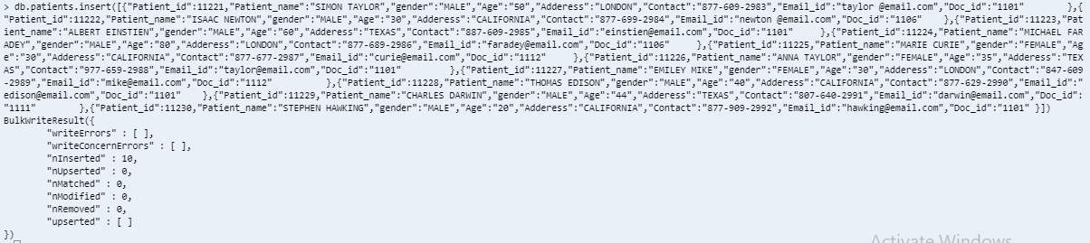

* **ctFiles.files**

db.createCollection("ctFiles.files ")

* **ctFiles.chunks**

db.createCollection("ctFiles.chunks ")

1. **File upload using Nodejs-gridfs-angular2 – Setup**

* git clone https://github.com/rahil471/fileupload-nodejs-gridfs-angular2.git
* cd fileupload-nodejs-gridfs-angular2/
* npm install
* In new terminal, started node server

node app.js

the node server started on port 3002

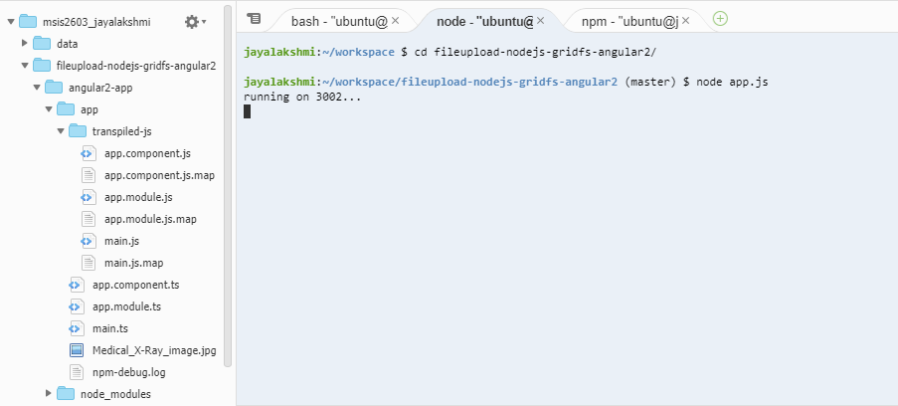

* Connection to the application:

cd angular2-app

npm start

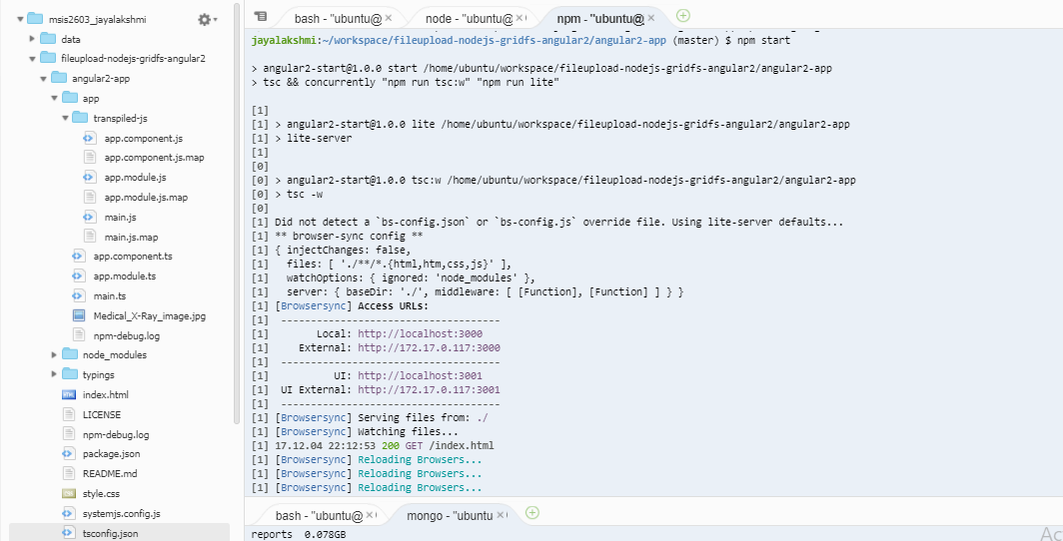

* angular2 app will be running on port 3000 and will open in browser as shown below. The images to be stored is uploaded

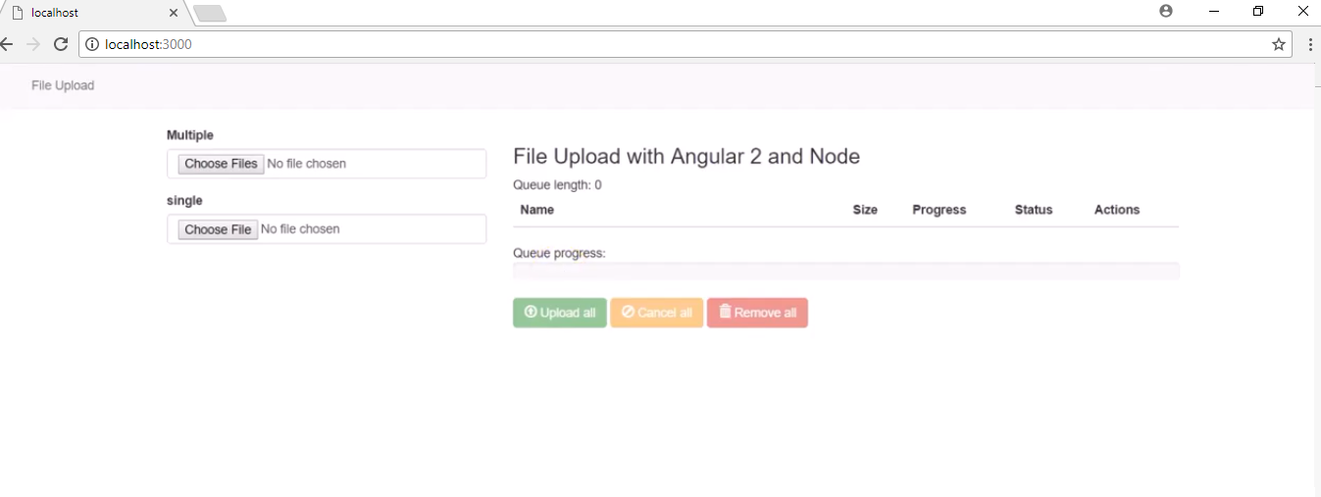

1. **Queries to upload and retrieve files:**

// Query to upload images

mongofiles -d database put Medical_X-Ray_image.jpg

//Query to retrieve images

mongofiles -d database get Medical_X-Ray_image.jpg

//Query to delete images

mongofiles -d database delete Medical_X-Ray_image.jpg

//Query to upload videos

mongofiles.exe -d gridfs put sample.mp3

//The below query uploads the bson data

./mongofiles –port 28017 -d gridfs put people.bson

1. **QUERIES:**
   1. **USER: RECEPTIONIST**
2. **To add new patient’s profile**

INSERT INTO PATIENT

(PATIENT_ID,F_NAME,L_NAME,GENDER, AGE,ADDRESS,CONTACT,EMAIL_ID,DOC_ID)

VALUES

('11292','SONIA','TED','FEMALE','32','CHICAGO','877-999-2983','sonia@email.com','1161');

**Before Insert:**



**After Insert:**

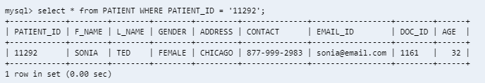

1. **When the patient’s email Id needs to be updated by the receptionist**

UPDATE PATIENT SET EMAIL_ID = 'RENNY@email.com'

WHERE PATIENT_ID = '11251';

**Before Update:**

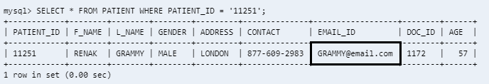

**After Update:**

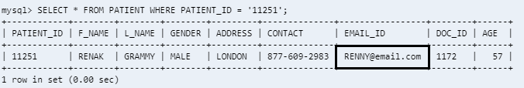

1. **To delete very old consultation details of patient**

DELETE FROM DIAGNOSIS WHERE EXTRACT(YEAR FROM DIAG_DATE) < 2018 ;

**Before deletion:**

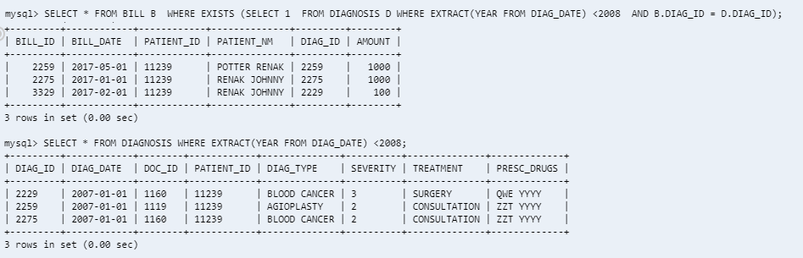

**After Deletion:**

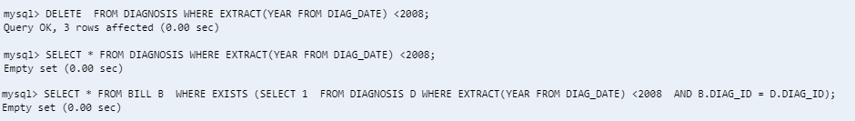

1. **To delete a particular patient’s details (may be upon death)**

DELETE FROM PATIENT WHERE PATIENT_ID = '11246';

**Before Delete:**

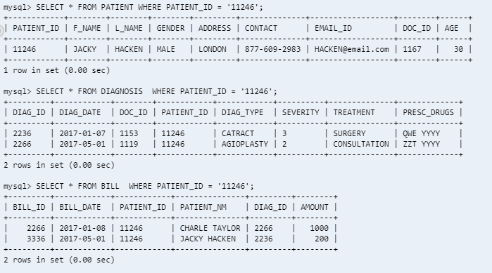

**After Delete:**

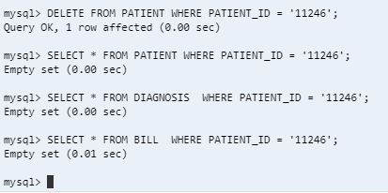

1. **USER: DOCTOR**
2. **When Doctor needs to add new diagnosis data of his existing patient**

INSERT INTO DIAGNOSIS

(DIAG_ID ,DIAG_DATE, DOC_ID, PATIENT_ID, DIAG_TYPE, SEVERITY, TREATMENT, PRESC_DRUGS)

VALUES

('2282' , '2017-07-04','1106' ,'11244','BLOOD CANCER' ,'1' ,'CONSULTATION','WJW RRB' );

**Before Insert:**

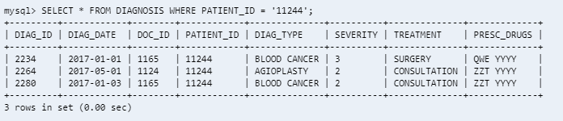

**After Insert:**

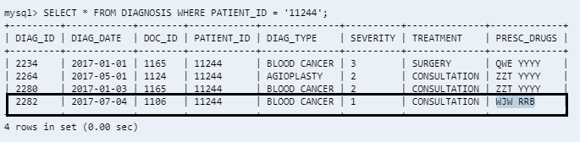

1. **When doctor access the patient’s history data**

SELECT

P.PATIENT_ID,

CONCAT(P.F_NAME,' ',P.L_NAME) AS PATIENT,

DG.DIAG_DATE ,

DG.DIAG_TYPE ,

DG.SEVERITY ,

DG.TREATMENT ,

DG.PRESC_DRUGS

FROM PATIENT P

JOIN DIAGNOSIS DG

ON P.PATIENT_ID = DG.PATIENT_ID

AND P.DOC_ID = DG.DOC_ID

WHERE P.DOC_ID = '1164'

AND P.PATIENT_ID = '11243'

ORDER BY DIAG_DATE DESC;

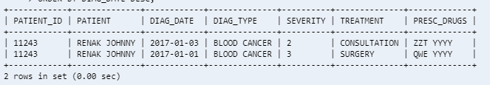

1. **When Doctor prescribes a change of drug for treatment**

UPDATE DIAGNOSIS SET PRESC_DRUGS = 'RAFAGA KFNVB'

WHERE PATIENT_ID = '11248'

AND DIAG_ID = '2238';

**Before Update:**

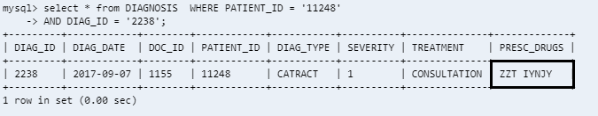

**After Update:**

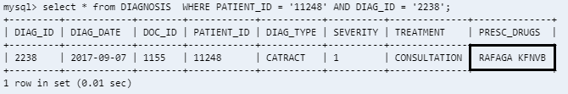

1. **USER: PATIENT**
2. **When user wants to access his profile details:**

SELECT * FROM PATIENT

WHERE PATIENT_ID = '11223';

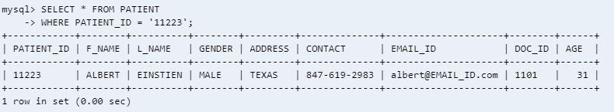

1. **When user needs to update any of his personal details:**

UPDATE PATIENT SET CONTACT = '877-654-7565'

WHERE PATIENT_ID = '11230';

**Before Update:**

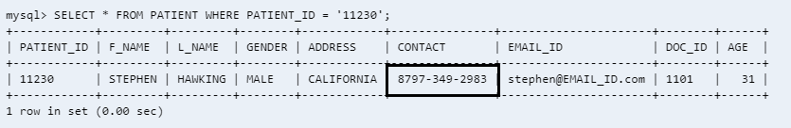

**After Update:**

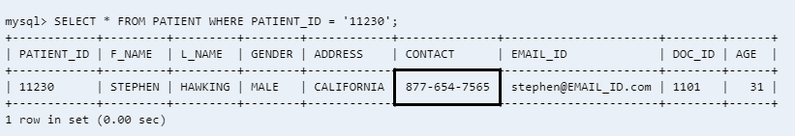

1. **To find the latest consultation details, maximum of 5 consultations**

SELECT

DOCTOR,

PATIENT_ID,

PATIENT,

DIAG_DATE ,

DIAG_TYPE ,

SEVERITY ,

TREATMENT ,

PRESC_DRUGS

FROM VW_SNAPSHOT

WHERE PATIENT_ID = '11231'

ORDER BY DIAG_DATE DESC

LIMIT 5;

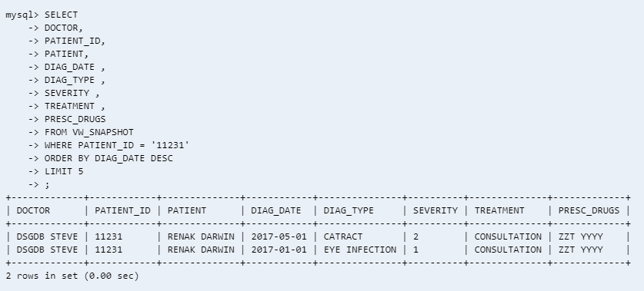

1. **USER: HOSPITAL MANAGEMENT**

**To analyze department-wise performance**

SELECT DP.DEPT_NAME AS DEPARTMENT,SUM(S.AMOUNT) AS REVENUE

FROM DEPARTMENT DP

JOIN DOCTOR D

ON DP.DEPT_NAME = D.DEPARTMENT

JOIN VW_SNAPSHOT S

ON D.DOC_ID = S.DOC_ID

GROUP BY DEPT_NAME

ORDER BY DEPT_NAME;

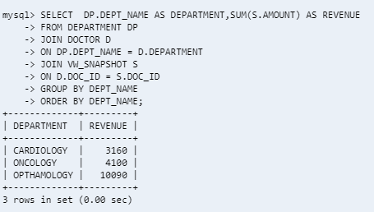

**TABLES**

SELECT * FROM DOCTOR LIMIT 12;

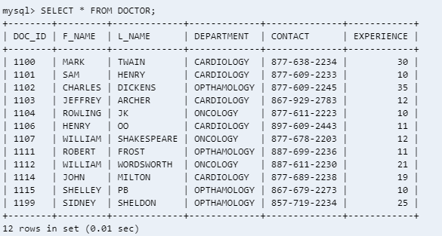

SELECT * FROM PATIENT LIMIT 10;

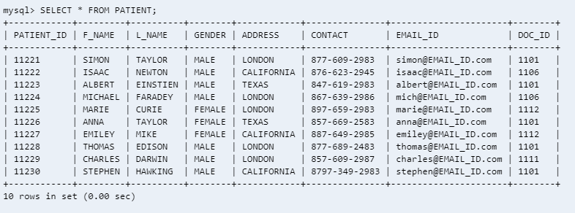

SELECT * FROM DIAGNOSIS LIMIT 10;

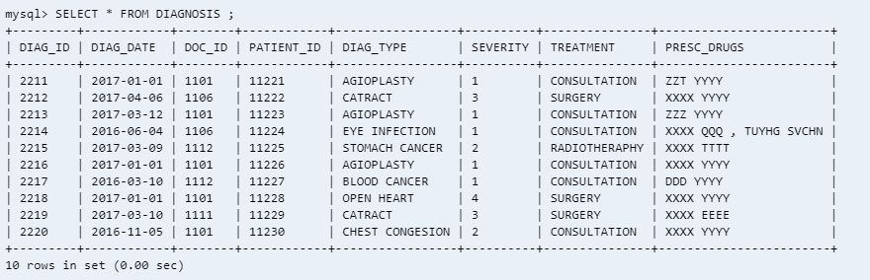

SELECT * FROM DEPARTMENT ;

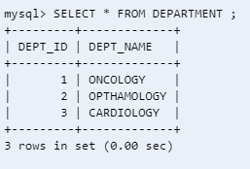

SELECT * FROM BILL LIMIT 10;

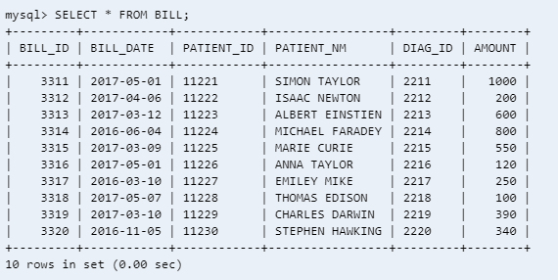

**VIEWS:**

CREATE VIEW VW_SNAPSHOT AS

SELECT

D.DOC_ID,

CONCAT(D.F_NAME,' ',D.L_NAME) AS DOCTOR,

P.PATIENT_ID,

CONCAT(P.F_NAME,' ',P.L_NAME) AS PATIENT,

DG.DIAG_DATE ,

DG.DIAG_TYPE ,

DG.SEVERITY ,

DG.TREATMENT ,

DG.PRESC_DRUGS ,

B.AMOUNT

FROM DOCTOR D

JOIN

PATIENT P

ON D.DOC_ID = P.DOC_ID

JOIN DIAGNOSIS DG

ON P.PATIENT_ID = DG.PATIENT_ID

AND D.DOC_ID = DG.DOC_ID

JOIN BILL B

ON P.PATIENT_ID = B.PATIENT_ID AND

DG.DIAG_ID = B.DIAG_ID

ORDER BY DG.DIAG_DATE;

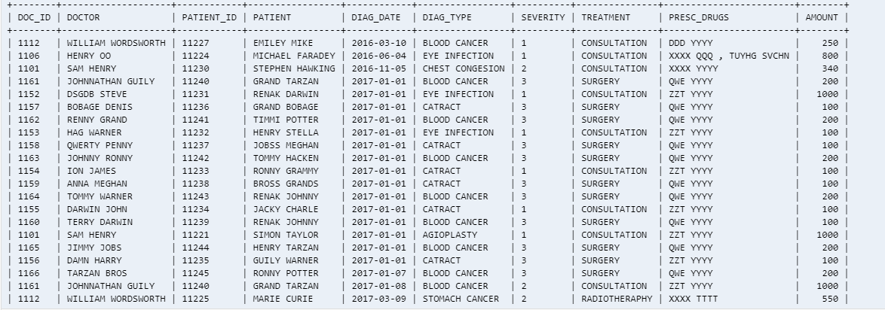

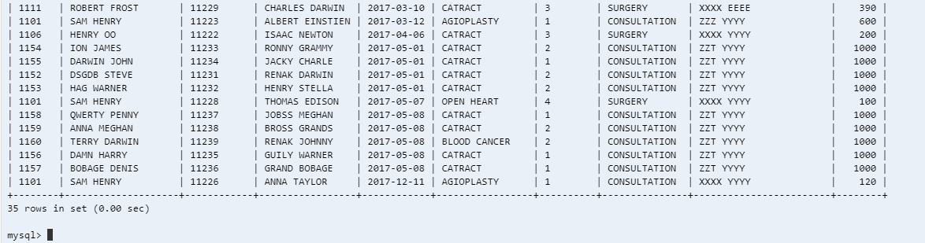

CREATE VIEW VW_DOC_PAT_RATIO_MAT AS

SELECT

CONCAT(D.F_NAME,' ',D.L_NAME) DOCTOR_NAME,

COUNT(P.PATIENT_ID)

FROM DOCTOR D

JOIN

PATIENT P

ON D.DOC_ID = P.DOC_ID

JOIN DIAGNOSIS DG

ON P.PATIENT_ID = DG.PATIENT_ID

AND D.DOC_ID = DG.DOC_ID

GROUP BY D.DOC_ID

ORDER BY DG.DIAG_DATE;

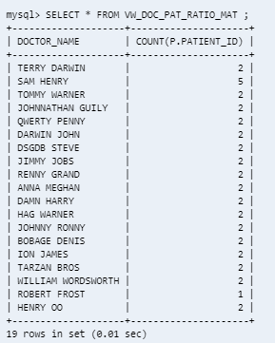

CREATE VIEW VW_AILMENT_DIST_MAT AS

SELECT

P.GENDER ,

DG.DIAG_TYPE,

COUNT(P.PATIENT_ID) COUNT

FROM

PATIENT P

JOIN DIAGNOSIS DG

ON P.PATIENT_ID = DG.PATIENT_ID

GROUP BY P.GENDER,DG.DIAG_TYPE

ORDER BY P.GENDER,DG.DIAG_TYPE;

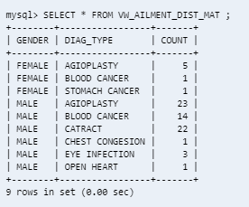

**STORED PROCEDURE:**

CREATE PROCEDURE REVENUE_METRIX

AS

BEGIN

SELECT A.YEAR,

A.MONTH,

SUM(A.AMOUNT) AS REVENUE_MAT

FROM (SELECT

EXTRACT(MONTH FROM BILL_DATE) AS MONTH,

EXTRACT(YEAR FROM BILL_DATE) AS YEAR,

AMOUNT

FROM BILL ) A

GROUP BY A.YEAR,A.MONTH

ORDER BY A.YEAR,A.MONTH

END;

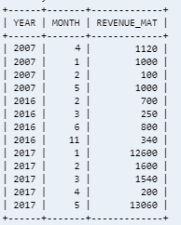

1. **NoSQL:**
   1. **USER: LAB TECHNICIAN**
      1. **To retrieve patient details:**

Db.patients.find({“Patient_id”:11221}).pretty()

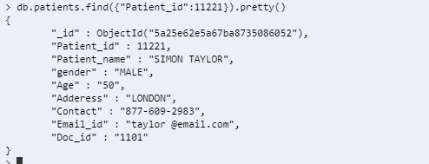

* + 1. **To retrieve and view the images in mongo:**
* **The metadata of the uploaded files are viewed as follows:**

Use gridfs

Db.ctFiles.files.find()

Meta data of uploaded files from collection ctFiles

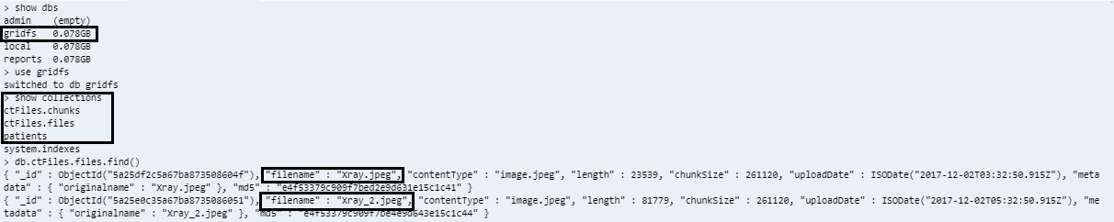

* Chunks of the uploaded files are viewed as:

Db.ctFiles.chunks.find()

Information about the chunks and the file id:

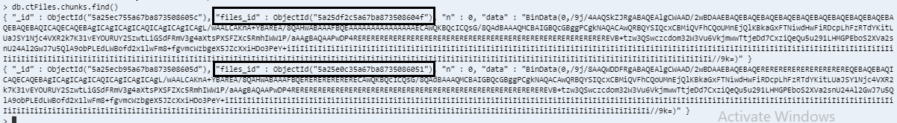

* + 1. **To retrieve and view the images in application**

By Typing the below host address the image is retrieved from Mongo DB into the application:

localhost3002/files/Xray.jpeg

Screenshot of the retrieved image from mongo

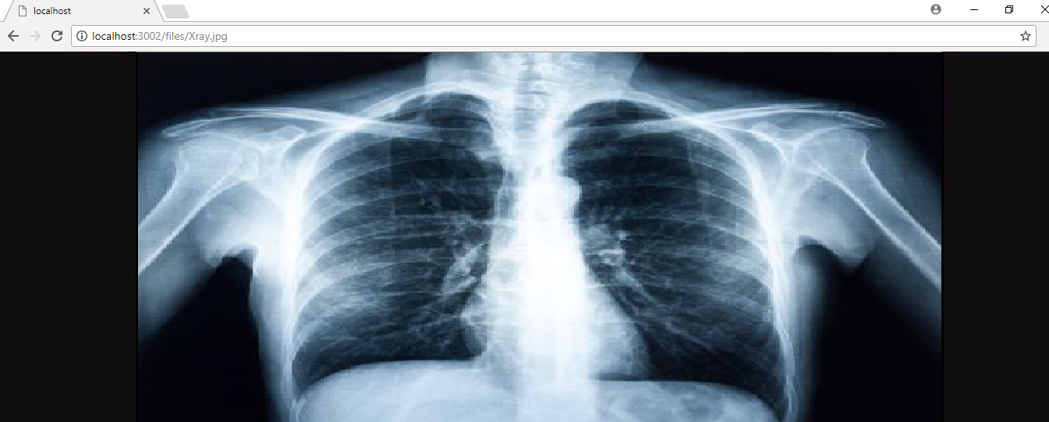

1. **BUSINESS MATRICS**
2. **Overall Snapshot of the hospital management – View**

SELECT * FROM VW_SNAPSHOT ;





1. **Revenue Metrics – Stored procedure**

EXEC REVENUE_METRIX;



Note: Despite the syntax for stored procedure being right, the procedure did not get executed in icloud9. Executed the select statement and derived the above result

1. **Doctor to Patient Ratio - View**

SELECT * FROM VIEW VW_DOC_PAT_RATIO_MAT LIMIT 4 ;

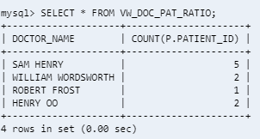

1. **Gender wise Ailment Frequency**

SELECT * FROM VIEW VW_AILMENT_DIST_MAT ;



1. **PERFORMANCE IMPROVEMENT:**

For performance improvement, indexing was used to tables **PATIENT, DOCTOR and BILL**.As table **DIAGNOSIS** requires frequent updating, indexing was not applied as it will slow down the update process. Refer below tabulation and screenshot for time taken to fetch data before and after indexing. The execution time has reduced after adding index to corresponding tables

Queries:

* CREATE INDEX idx_pat_pat_id

ON PATIENT (PATIENT_ID);

* CREATE INDEX idx_doc_doc_id

ON DOCTOR (DOC_ID);

* CREATE INDEX idx_bill_bill_dt

ON BILL (BILL_DATE);

|  |  |  |  |
| --- | --- | --- | --- |
| **Query_ID** | **QUERIES** | **DURATION WITHOUT INDEX** | **DURATION WITH INDEX** |
| 1 | SELECT A.YEAR,A.MONTH,SUM(A.AMOUNT) AS REVENUE_MAT FROM (SELECT EXTRACT(MONTH FROM BILL_DATE) AS MONTH,EXTRACT(YEAR FROM BILL_DATE) AS YEAR,  AMOUNT  FROM BILL ) A  GROUP BY A.YEAR,A.MONTH  ORDER BY A.YEAR,A.MONTH ; | 0.000532 | 0.0003015 |
| 2 | SELECT * FROM VW_SNAPSHOT ; | 0.00110075 | 0.0005615 |
| 3 | SELECT * FROM VW_DOC_PAT_RATIO; | 0.00126275 | 0.00014575 |
| 4 | SELECT * FROM VW_AILMENT_DIST_MAT ; | 0.00086425 | 0.00052375 |
| 5 | SELECT * FROM PATIENT WHERE PATIENT_ID = '11223' ; | 0.00037675 | 0.00015275 |
| 6 | SELECT DOCTOR,PATIENT_ID,PATIENT,DIAG_DATE ,DIAG_TYPE ,SEVERITY ,TREATMENT ,PRESC_DRUGS FROM VW_SNAPSHOT WHERE PATIENT_ID = '11231' ORDER BY DIAG_DATE DESC LIMIT 5 ; | 0.0011355 | 0.00047475 |
| 7 | SELECT P.PATIENT_ID,CONCAT(P.F_NAME,' ',P.L_NAME) AS PATIENT,DG.DIAG_DATE ,DG.DIAG_TYPE ,DG.SEVERITY ,DG.TREATMENT ,DG.PRESC_DRUGS FROM DOCTOR D   JOIN PATIENT P ON D.DOC_ID = P.DOC_ID JOIN DIAGNOSIS DG ON P.PATIENT_ID = DG.PATIENT_ID AND D.DOC_ID = DG.DOC_ID JOIN BILL B ON P.PATIENT_ID = B.PATIENT_ID  AND  DG.DIAG_ID = B.DIAG_ID   WHERE D.DOC_ID = '1166'  AND P.PATIENT_ID = '11245' ORDER BY DIAG_DATE DESC ; | 0.000723 | 0.000433 |
| 8 | SELECT DP.DEPT_NAME AS DEPARTMENT,SUM(S.AMOUNT) AS REVENUE FROM DEPARTMENT DP JOIN DOCTOR D ON DP.DEPT_NAME = D.DEPARTMENT JOIN VW_SNAPSHOT S ON D.DOC_ID = S.DOC_ID GROUP BY DEPT_NAME ORDER BY DEPT_NAME ; | 0.0011335 | 0.00107425 |

**Screenshot without indexing:**

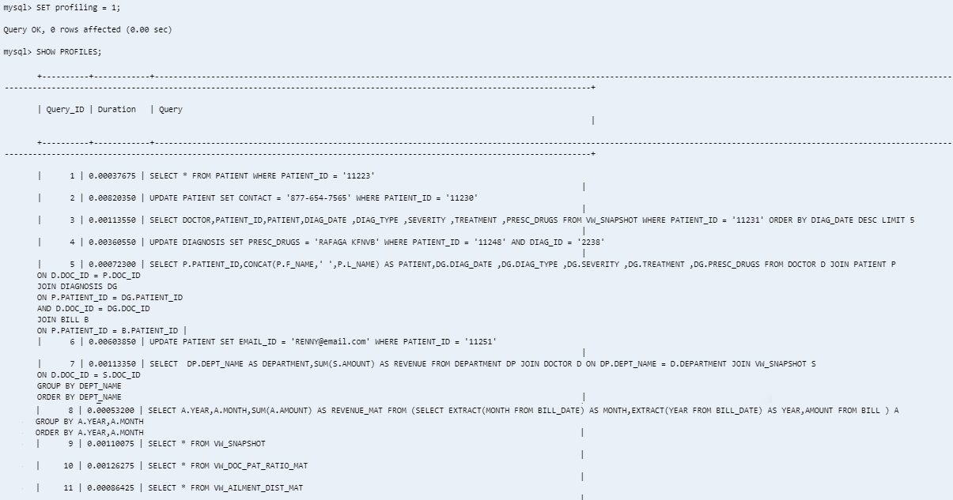

**Screenshot After Indexing:**

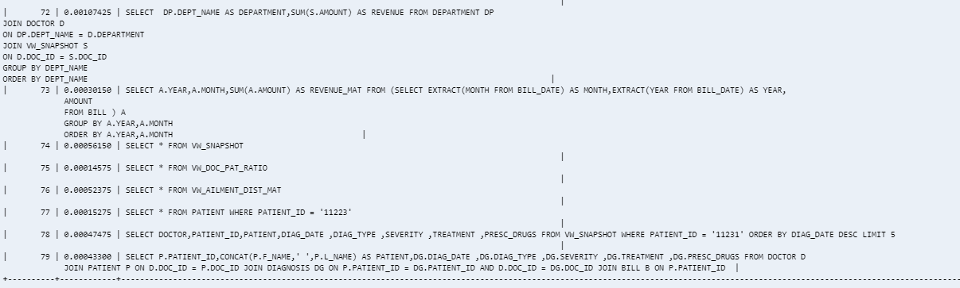

**Sample:**

SELECT DP.DEPT_NAME AS DEPARTMENT,SUM(S.AMOUNT) AS REVENUE

FROM DEPARTMENT DP

JOIN DOCTOR D

ON DP.DEPT_NAME = D.DEPARTMENT

JOIN VW_SNAPSHOT S

ON D.DOC_ID = S.DOC_ID

GROUP BY DEPT_NAME

ORDER BY DEPT_NAME;

From below screenshots its clear that the number of rows processed for the above query has reduced after indexing.

Before Indexing:

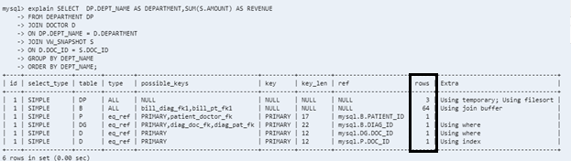

**After Indexing:**

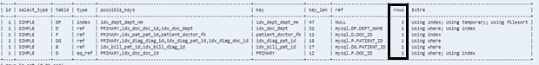

1. **SUMMARY:**

The project gave me hands on experience on SQL and NoSQL. Gained deeper knowledge on handling Database - starting from design, implementation and validation of a database application. Also, explored the file handling features of mongo using Nodejs and GridFS starting from installation to file data retrieval. Got a better perspective of DBMS from a business point.

1. **hardest part of this project**

* Installation and implementing the GridFS and mongofiles features using Nodejs
* Performance improvement for SQL
* Populating source dataset for both structured and Unstructured DB
* Deciding between SQL Vs NoSQL

1. **problems faced this project**

* Designing the management system
  + Choosing the tables and their attributes were challenging
  + Framing the relationship between the tables
  + Designing views and stored procedure for Business Metrics
* Execution errors while deploying the code
* Performance improvement for SQL
* Choosing the appropriate attribute to perform indexing was challenging
* Preparing large dataset for testing the performance improvement code consumed more time
* Installation and implementing errors while using Nodejs feature to upload images and vidoes as mongofiles

1. **How was the problem solved?**

* **Designing the management system**
* The table attribute and constraints were planned and penned down before writing the scripts.
* The views and stored procedures were also designed based on the Business Metrics requirements
* **Execution errors while deploying the code**

Based on the error code returned, corresponding solution were referred online and the errors were fixed

* **Performance improvement for SQL**
* Major impacting columns were identified. Indexing was applied to those columns. The time taken to execute the queries before and after applying index were noted and compared.
* indexing was used to tables **PATIENT (PATIENT_ID), DOCTOR (DOC_ID) and BILL (BILL_DATE)**.
* As table **DIAGNOSIS** requires frequent updating, indexing was not applied as it will slow down the update process.
* **Installation and implementing errors while Using Nodejs feature The file upload was done using Nodejs,gridFs features of mongo**
* Referenced SQL MogoDB manual
* The fix for the error codes were searched in various forums online
* Referenced <https://github.com/rahil471/fileupload-nodejs-gridfs-angular2>
* For the Nodejs setup

1. **If I were to do this project again**

* Include Trigger on deletion of records from tables. Since hospital data are very confidential and important it is necessary to record the changes done to data. Also,they can be referred incase of auditing or any future purpose
* Include sharding features in NoSQL for performance improvement
* Improvise on the design by analyzing the real hospital scenario
* Include trend analysis for each patient based on the Lab test results in NoSQL
* Expand the scope to handle Drug Department

1. **Reference:**

<https://github.com/rahil471/fileupload-nodejs-gridfs-angular2>

<https://www.w3schools.com/nodejs/nodejs_mongodb_createcollection.asp>